Radiography Volunteering in Tanzania – 2011
Paul Hayllar
Student Radiographer
Canterbury Christ Church University

"The trials and tribulations of Tanzania"

Making Plans

During the long flight home from Nepal 2010, I reflected on the previous six weeks of Medical Volunteering in Kathmandu. The experience has opened my eyes to the exciting possibilities that Radiography could bring in the future. Without question living within the community and working in a healthcare system of a developing country creates unique challenges and learning opportunities. During the final decent into Heathrow, my reflection had resulted in one main question. Where to volunteer next year?

The answer was Tanzania

Tanzania is East Africa’s largest country situated just south of the equator. It boasts several world famous features such as Zanzibar; Kilimanjaro; Ngorongoro Crater and the Serengeti plains. With a population of 42.7 million, life expectancy is only 52; there are, 1.4 million people living with HIV/AIDS resulting in 86,000 deaths per annum (4th highest in the world) in addition to very high risk from infectious diseases such as Malaria and Hepatitis A¹.

After researching Radiography in Africa^{2,3,4} I found myself back at Heathrow checking in for my next volunteering adventure. The health system of Tanzania assumes a pyramidal pattern comprising of six levels⁵. I requested to work at a government district hospital (level 4)⁵ as 70% of the population reside in rural areas. I would have the opportunity to experience a range of facility standards, conditions and illnesses that are not seen in the United Kingdom (UK).

The Hospital

Various modes of transport were required to travel from the volunteer house to the district hospital. First a taxi, to the main highway in Arusha, then you would place you life in the hands of the dala dala driver. The dala dala’s are very small mini buses with 12 seats; the most that got squeezed into one of ours was 29 people!

The district hospital lies 16 miles to the East of Arusha. In 1968 it held the status of a first level Rural Health Centre and in 1986 it was upgraded to a District Hospital after considerable expansion. The Hospital performs as a referral centre for two health centres and twenty-four dispensaries, serving a population of 270,907⁶.

The 120 bed Hospital has both inpatient and outpatient facilities including Reproductive and Child Health, Physiotherapy, Care and Treatment Clinic (HIV/AIDS-related services), Oral Health Clinic, TB/Leprosy Unit, Eye Clinic. In addition the hospital has Maternity facilities and an Infectious ward (for TB and Rabies). Additional services are Radiology (x-ray and ultrasound), Pharmacy, Laboratory, Major and Minor surgical theatres.

I was given an induction tour by two English Doctors who were also living at my volunteer house. The hospital layout consisted of one main road through the centre and on each side single storey buildings housing each department. It was clear from the outside, that the buildings had seen better days; inside was sparse to say the least. Just from the walk around you could get a feel for the serious lack of resources with even basic equipment such as oxygen not being present apart from in major theatre.

On the way to X-ray, I was introduced to Matron who gave me a very warm welcome stating that they had been looking forward to the English Radiographer’s arrival! We have lots of work for you to do! OK, that’s great I replied – but I must say I am a second year student and not fully qualified yet. This statement really did not seem to matter, in her eyes I was there to work.

Xray Department

To my surprise the x-ray staffing structure was extremely simplistic as the Hospital only had one Doctor of Radiography’ (Radiographer) and one receptionist. The Dr had been qualified for 3 years after studying an Advanced Diploma in Radiography at Bugando University. It was clear from the outset that he really enjoyed his work and was very welcoming. The Radiographer is always very happy to see volunteers, as running x-ray, film processing and ultrasound simultaneously is a challenge for anyone.

As the days developed, I discovered how it felt to be a truly autonomous practitioner. The Radiographer’s scope of practice has to include additional skills, facilitating the patient’s pathway to completion.

Radiographers Scope of Practice

Justification of request

Patient Assessment – Visual, Verbal and Physically

Required Views – With limited resources commonly only one view undertaken

Position & Expose
Process Plain Film
Image Interpretation & Report
Refer or Treat
Treatment – Manipulation (in the x-ray room with no pain relief!) and applying POP
Fig 1.

X-ray Equipment

The x-ray equipment is a World Health Organisation (WHO) Basic Radiology System (BRS) the BRS was initially envisioned to be utilised by communities in need of radiographic services⁷.

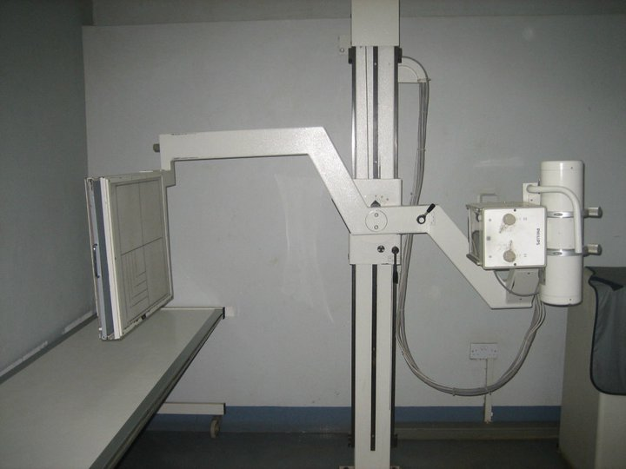
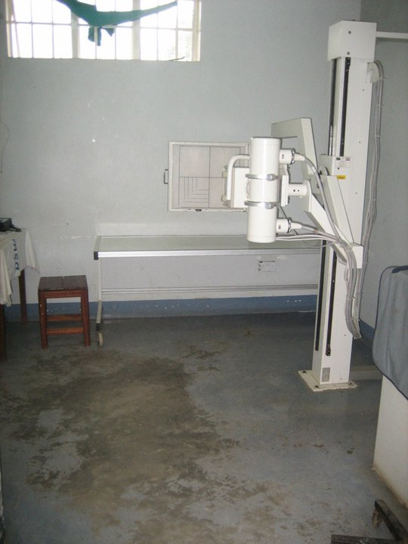

Fig. 2 Fig. 3

The x-ray room is compact and showing signs that it is very well used. The room contained the consultation area; viewing area, control panel and reception access.

The dark room equipment really could do with some money being spent as you can see from the images below.

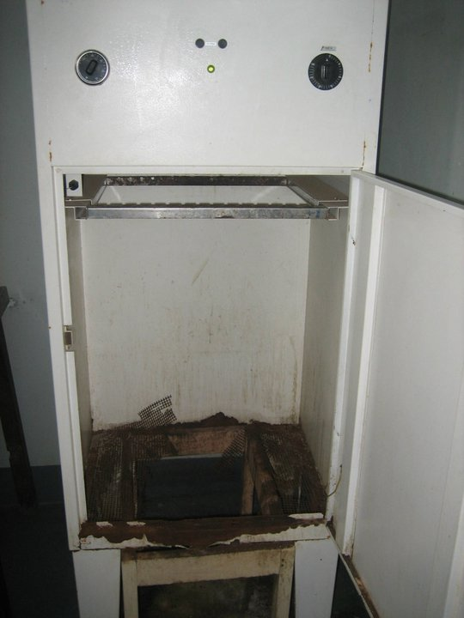
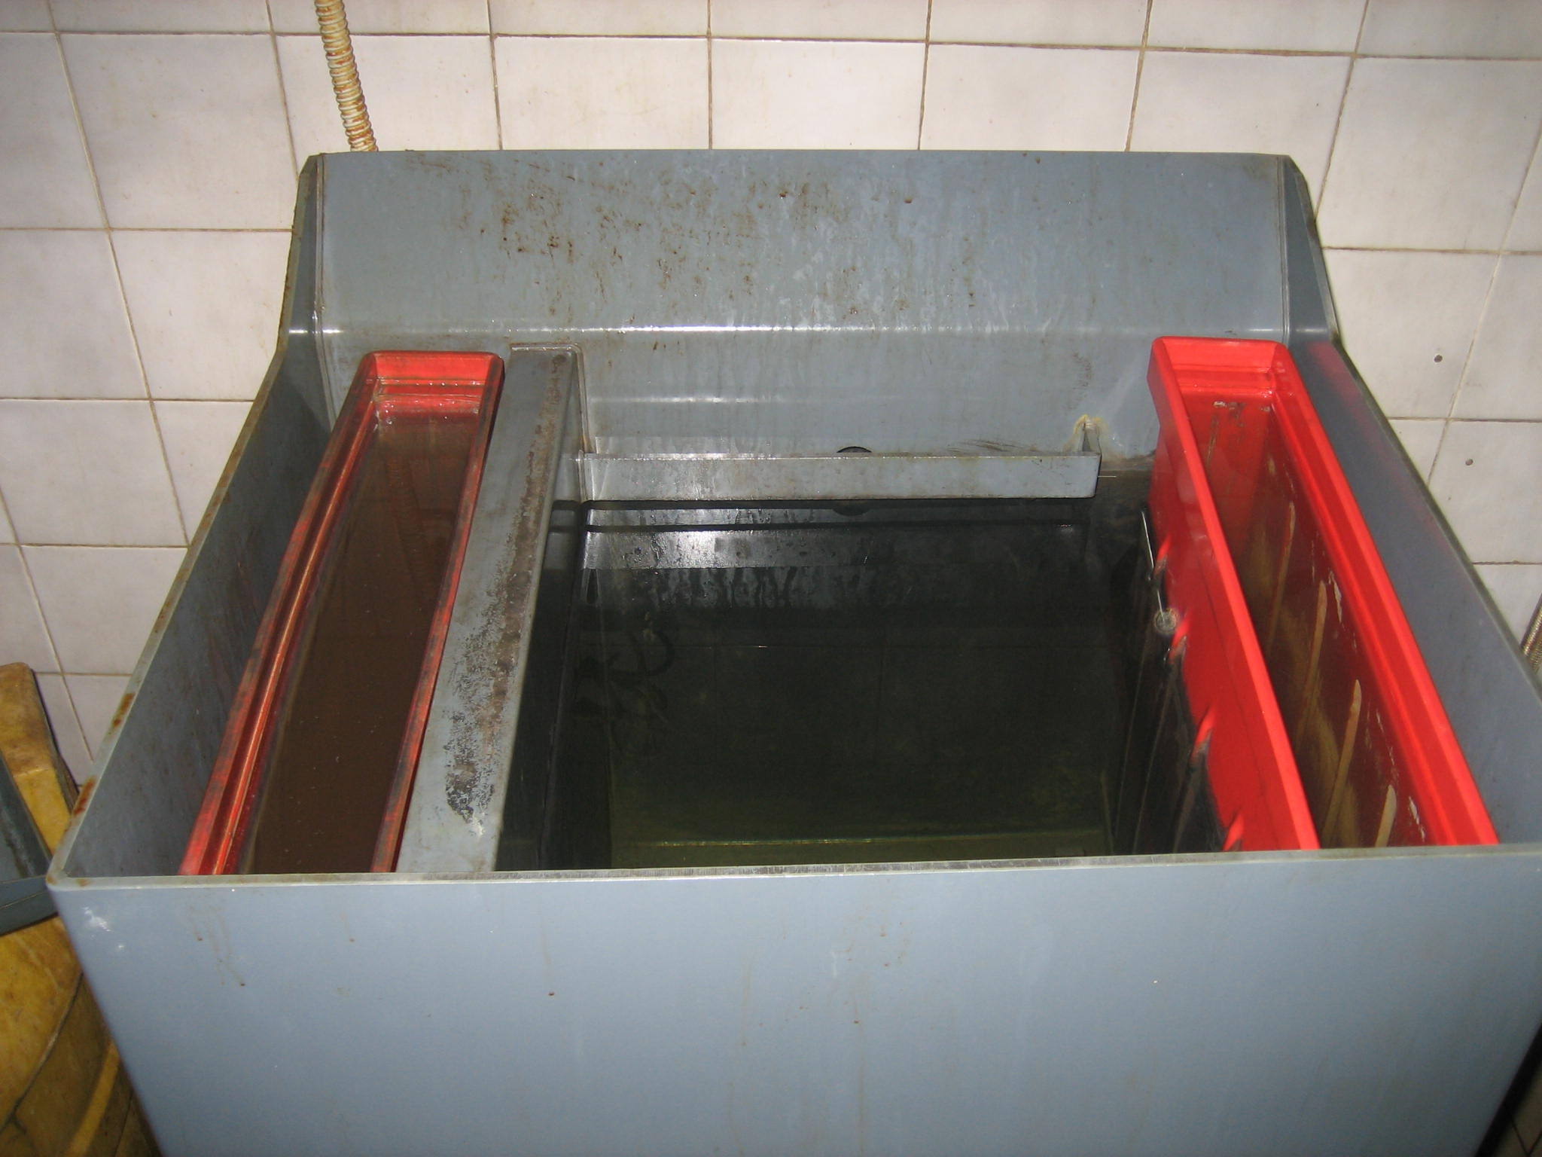
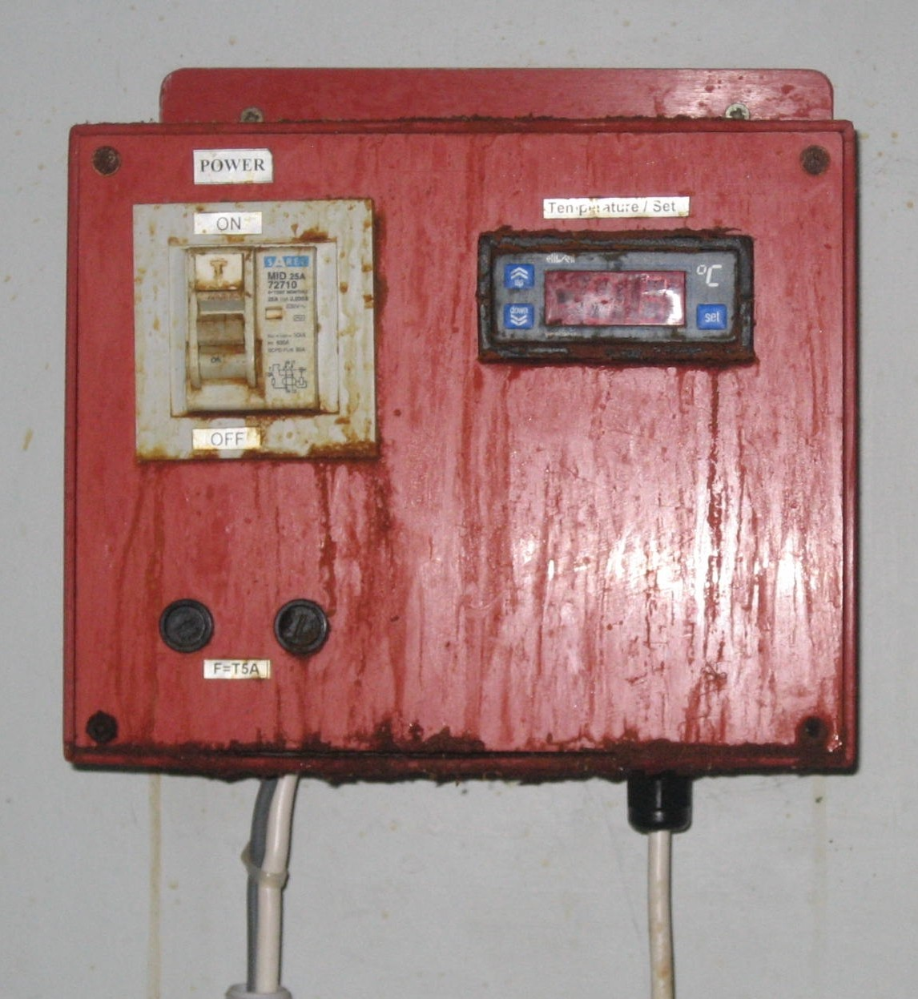

Fig. 4 Fig. 5 Fig. 6

After a rapid dark room training session from another volunteer, which equated to watch one (in complete darkness!) do one then teach one. I often found myself elbow deep in the hydroquinone and phenidone developer searching for a film that has dropped from the clip frame.

A reflection on my experience

It was clear from day one the Radiographer was out to test me to ascertain my skill level. I always continued to stand my ground on the views required after assessing the patient and, as I managed to position some very awkward trauma cases early on, his confidence in my skills grew rapidly.

As soon as I had proved my competence, I was told to “just proceed Mr Paul!” Thankfully a Canadian pre-med student helped me call the patients and process films, as her Swahili was much better than mine!

Throughout my time at the hospital, most mornings experienced a delay in starting, usually due to there being no electricity, regional power cuts were a daily occurrence. X-ray did have a small diesel generator, great I thought – until I discovered that there was no diesel! The saying TIA, was always used when this happened. TIA = This Is Africa! Life just does not have the same urgency as at home. Patients with obviously fractured bones just sat patiently outside, whilst the Radiographer bartered with the petrol station for some more diesel. The speed of x-raying the patients and processing the films was therefore directly proportionate to the quality of diesel acquired. The biggest challenge came on a day when I was told that there was just about 45 minutes worth of power to get through the full days’ worth of patients!!

In addition to having no power we also suffered from limited mains water, occasionally it came on, maybe once week. The water within the film-processing tank would turn to a very muddy brown colour overnight, but we had no choice but to use it. This was my first experience of wet processing; even I knew this could not be good for the film. Just as I was getting used to the dark room experience the bulb decided to blow in the direct filtered light. The indirect filtered light was hanging limply from the wall - it had not been working for months since it overheated and melted. It goes without saying that there was no, so myself and the radiographer scoured the entire hospital armed with a screw driver looking for any light from where we could ‘borrow’ a suitable bulb. Not one could be found! So as the Radiographer drove off into Arusha for a new bulb, I gave processing the films a go in complete darkness. After considerable guesswork to my surprise the films that came out were of diagnostic quality.

The patient’s with whom I worked showed the most extraordinary patience throughout all of these delays and disruptions. Not once did anyone ask when they’d be seen, without exception patients were seemingly understanding and very compliant to any request that we made of them. My thoughts often returned to home and tried to picture the chaos and complaining that any of these delays would have caused in the NHS!

Every day, I loved going to work knowing that I would experience something new every day. From working with HIV & AIDS positive patients, stabbings and brutal assault victims, non-accidental injuries, road traffic accidents and sometimes the most seemingly bizarre mechanisms of injury such as a request card stating that the patient had been assaulted by his Cow! Incidently this’ assault resulted in a displaced spiral fracture of his left Tibia.

Many patients stick in my mind. One was ‘wheeled’ in on a white plastic garden chair - which had been strapped - to the remains of a wheelchair with just the metal rims remaining on the wheels. I read his form, x-ray left lower leg ? #. On examination I could clearly see the tibia was displaced and crepitus could be palpated. As his friends lifted him out of the chair and onto the table I guessed that he was in his mid-forties, as the majority of patients do not know what year they were born and the form had no date of birth. Due to the shortage of films and department protocol I only undertook a long AP of his Tibia and Fibula. As the patient was lifted back to his chair he left a nice trail of blood from his left hand which had been covered with a piece of chequered cloth. I asked him to remove it and to my surprise the distal phalanges of his 4th and 5th had been traumatically removed; resulting in bony fragments being exposed. He hadn’t thought to mention this! It transpired that the patient had been assaulted by a security guard and was the recipient of some of the contents of a shotgun (luckily most missed him). On further investigation a number of shotgun pellets had penetrated his left anterior and medial deltoid. After palpating the area I could feel a number of pellets located within the muscle. My next challenge was to position him for a PA hand and proximal AP humerus on a small film as we had run out of the long films. The resulting images although not perfect, clearly showed the foreign bodies.

On the rare occasions I did manage to observe some other areas of the hospital. A heavily pregnant patient was brought to x-ray for an ultrasound scan we rushed her to theatre for an emergency caesarean section. After finding some enormous scrubs to put on I went into theatre, our patient had to wait as another man was already on the table but as soon as he was done our pregnant lady had to walk into theatre - from the pre-med area completely naked and climbed onto the table. As the room was being prepared she was clearly cold and distressed, so I asked the sister if we had anything we could use to cover her whilst she waited. I think I knew that the answer would be ‘No’, even before I asked but I had to try. There is a huge cultural difference with regards to patient dignity from what we are used to in the UK. The baby was successfully delivered and mum and baby are doing well.

Radiation Protection and Quality Control

I found a marked difference in Radiation Protection from my experience in Nepal to my time in Tanzania as the Radiographer was clearly following good protocols whilst working within a room with some limitations in design. Whilst working together further possible improvements were highlighted but implementation may take some time as resources are extremely limited.

On the other hand quality control (QC), performance and maintenance (PM) of the equipment could be questioned. Research in 2006 had evidenced the need for QC and PM policies to be created throughout Tanzania⁸. But within my hospital placement the x-ray department did not have the facilities to undertake even the most basic QC and the previous annual maintenance visit had resulted in the tube’s vertical adjustment being so tight it required all my strength just to move it up or down.

The highlight of my trip

In my last week I arranged to undertake a night shift with three other volunteers in the maternity department. In an attempt to maximise my experience, I decided to work a triple shift, Tuesday day shift in x-ray then move to maternity for 6.00pm work through until 8.00am then stumble over to x-ray for as long as I could last. Wednesday was always busy in x-ray as it was market day and people could afford treatment after selling their stock. In total I managed to work for 32 hours straight, although that sounds a lot I would not have changed it for anything.

The facilities in the maternity ward were basic to say the least, fig.7 shows the delivery area.
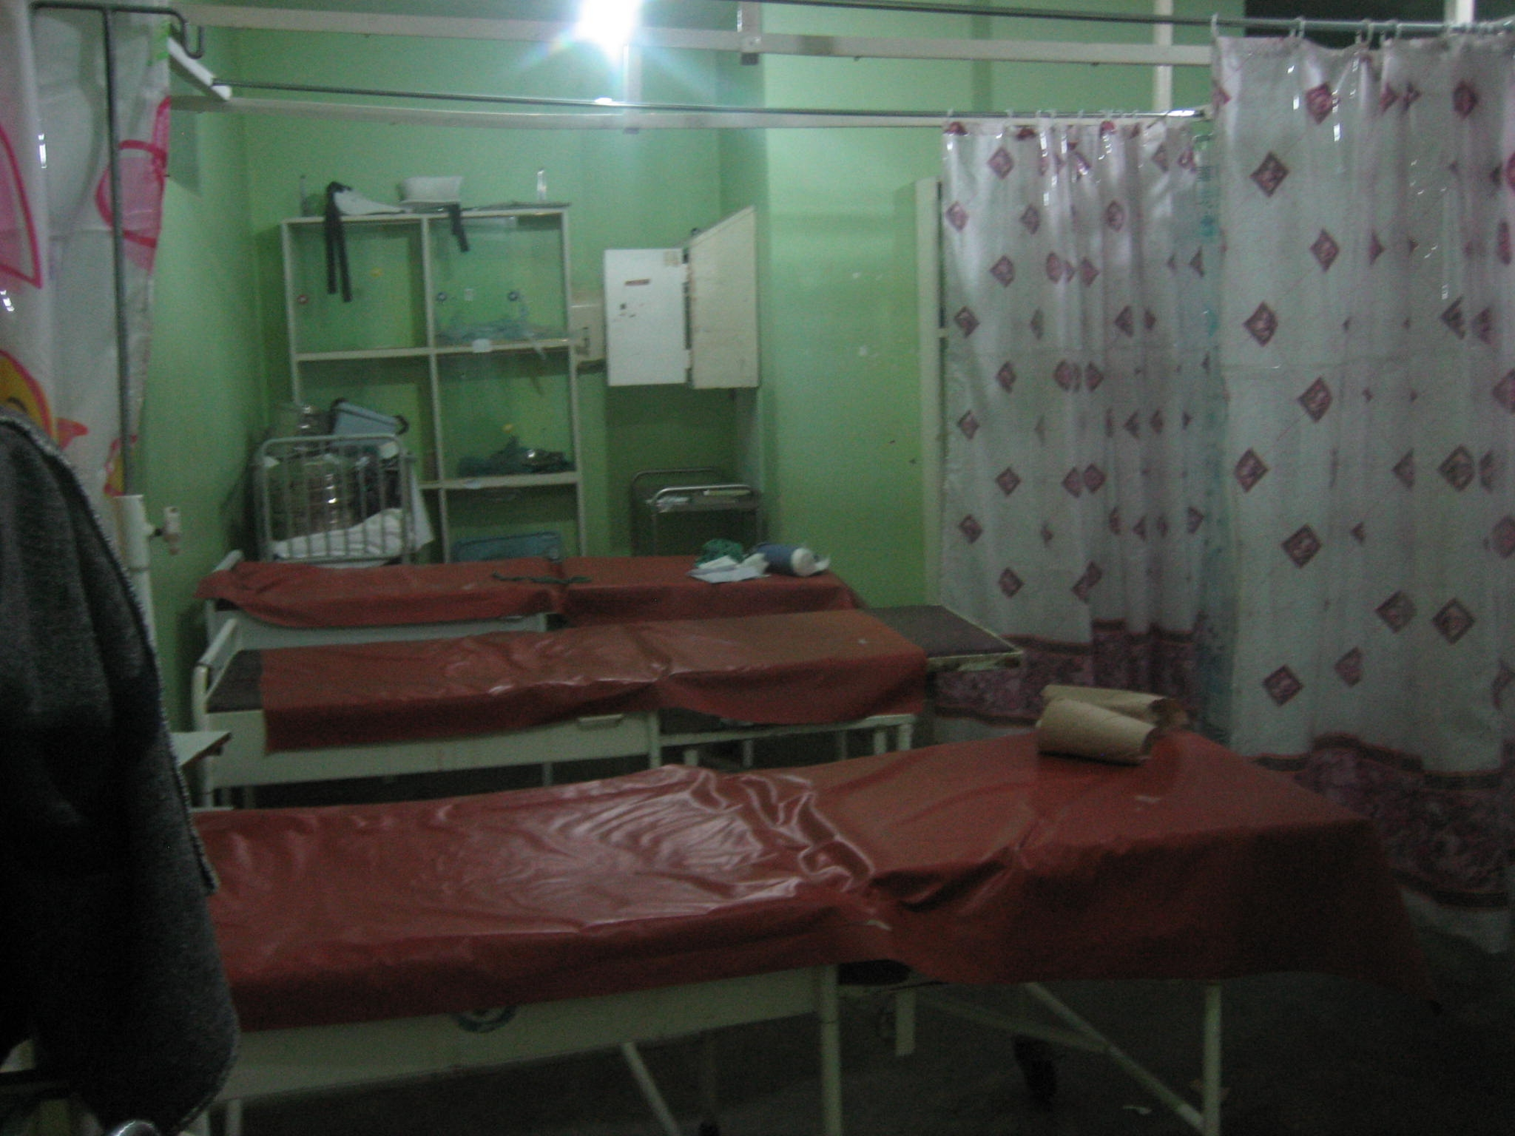

Fig. 7
The evening started at a good pace, the first three babies were all natural births, with just one having complications. The two very capable sisters working the night shift were keen for us all to be involved by preparing the sterilised kits, oxytocin injections or cleaning up and disposal of the placenta. The tasks developed as the night went on and included undertaking internal examinations and administering the intramuscular injections.

At 11.30pm we lost power, we found one torch and three kerosene lamps but only the torch and one lamp worked. So these were kept with us in the delivery area, I have to say that the ladies were absolutely amazing. They would come in, make no fuss, no screaming, NO pain relief!! Work so hard to push the baby out and then no rest straight up and off they take themselves to the postnatal ward.

At around 2.30am all three-delivery beds were in full swing and with just two sisters one of the other pre-med volunteers jumped in and delivered his first baby. Whilst he was doing that I was in the middle of the room holding the kerosene lamp in one hand, torch in the other and a mobile phone torch in my mouth! It had to be one of the most surreal moments of my life but what teamwork! Afterwards sister said ‘the next one you can do’! I had to wait for hours, but at 6.00am, I was honoured to deliver my first baby and undertook everything from start to finish. Simply the most amazing thing I have ever done and I will never forget it.
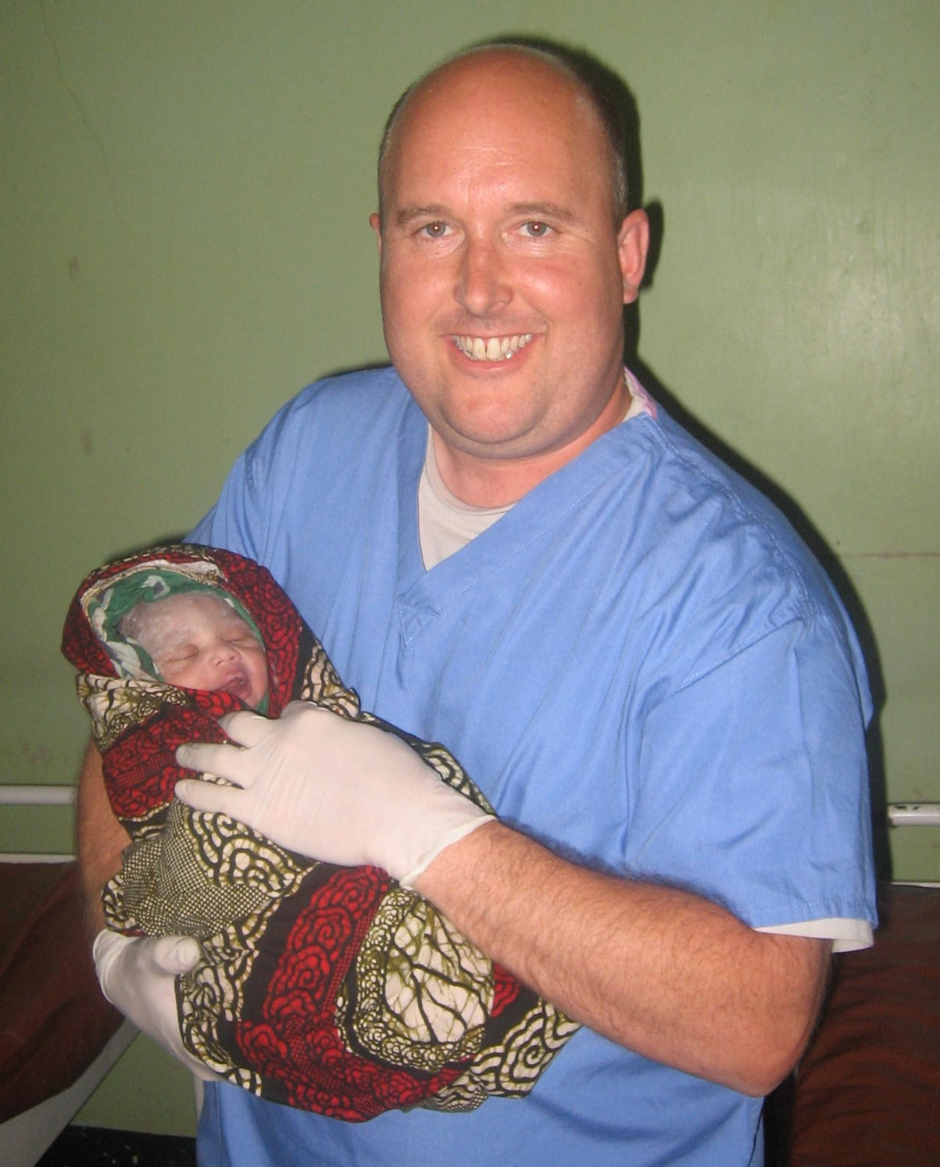

Fig. 8

In Conclusion

The experience I have gained from this relatively short period of time in Africa has simply been priceless. I have grabbed every opportunity with both hands (quite literally at tiems) and I feel that I have developed greatly both as an individual and future Radiographer. I would love to find a Radiography role in the future that would enable me to continue to visit developing countries with the aim to help develop staff training and departmental protocols.

I am still in regular contact with the Radiographer and would very much like to try and source any pieces of redundant equipment in the UK, such as empty cassettes, positioning foam, clip frames, dark room lights and radiography text books. If anyone can help please do not hesitate to contact me on ph133@canterbury.ac.uk

Photo Gallery

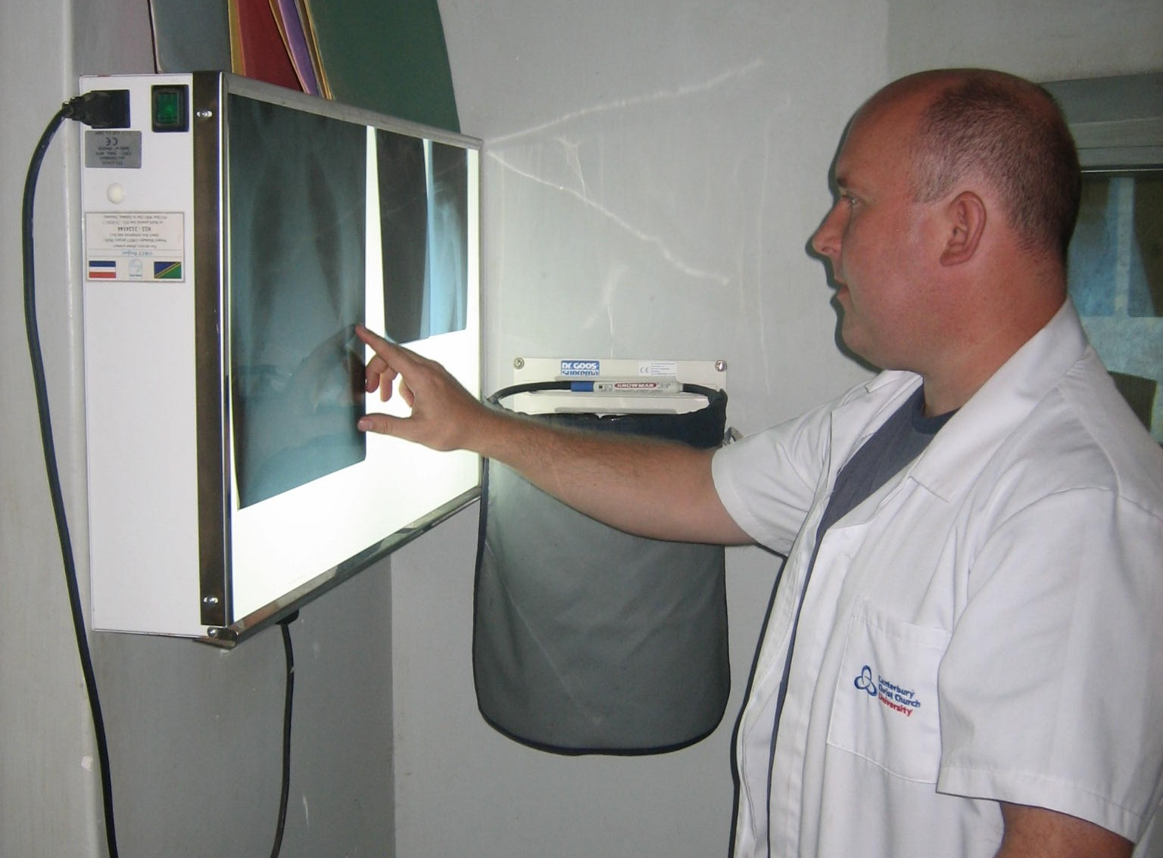
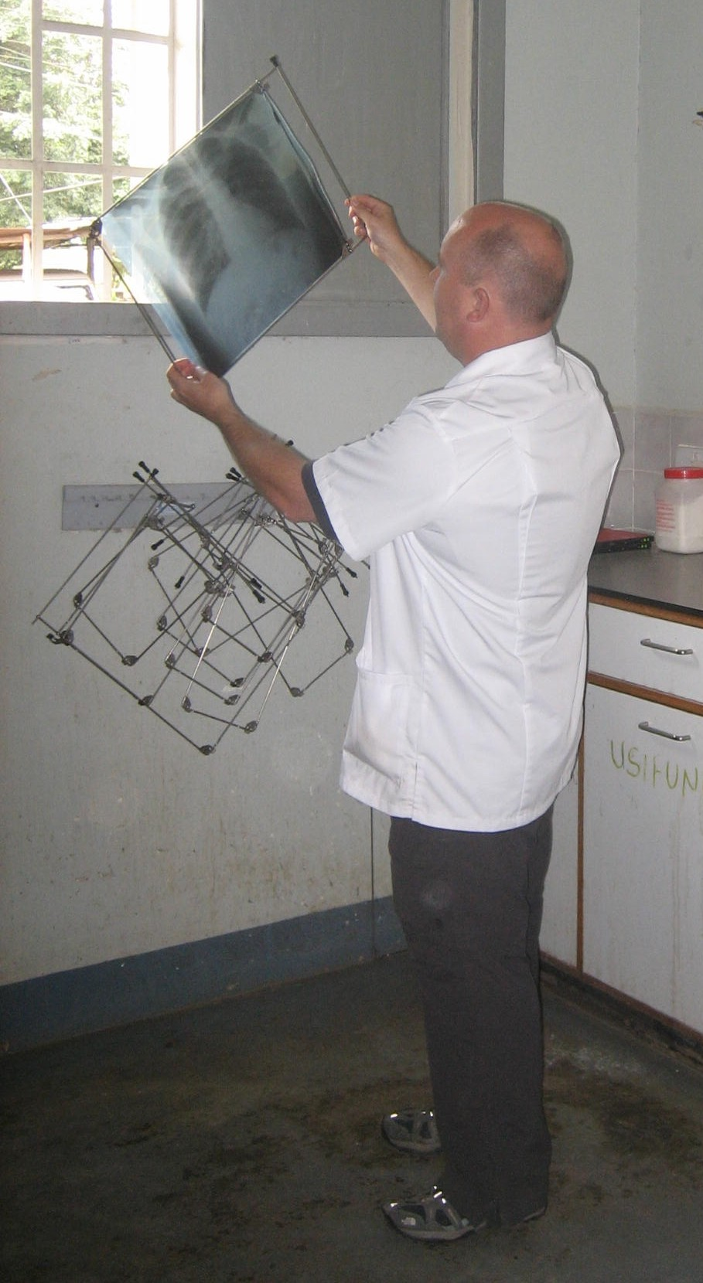

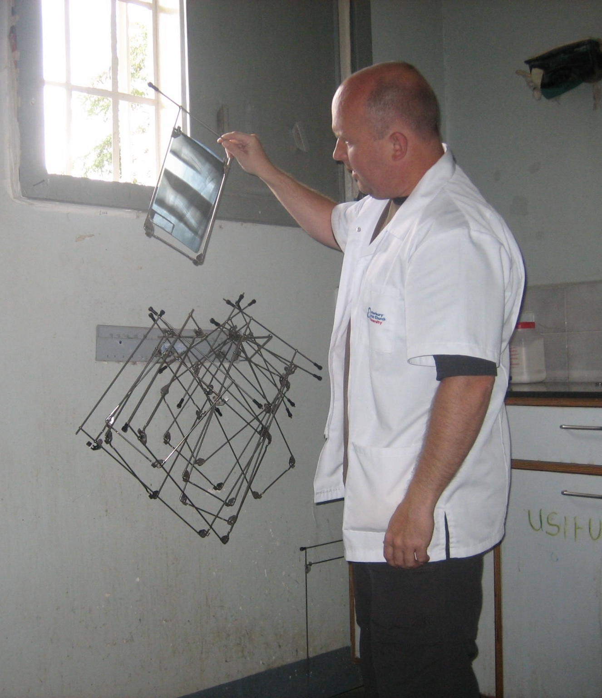

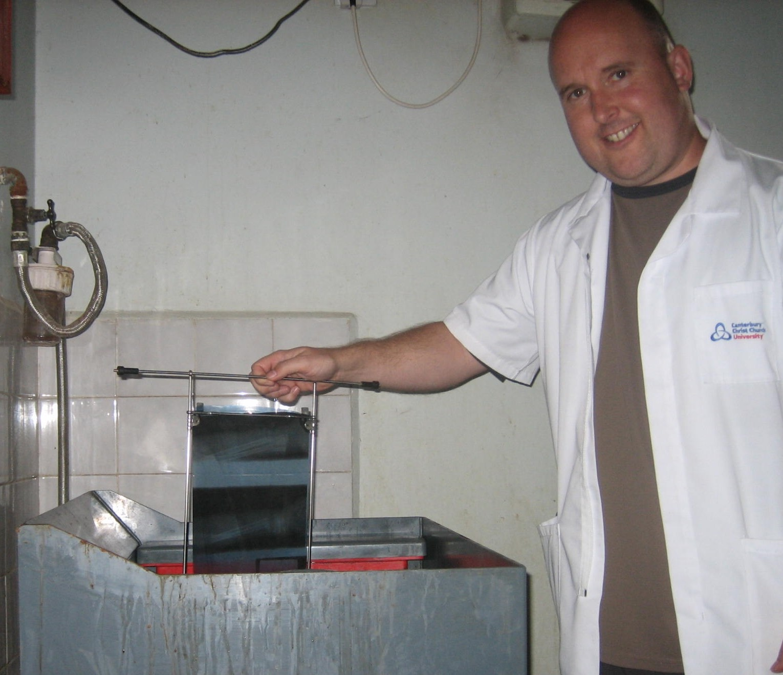

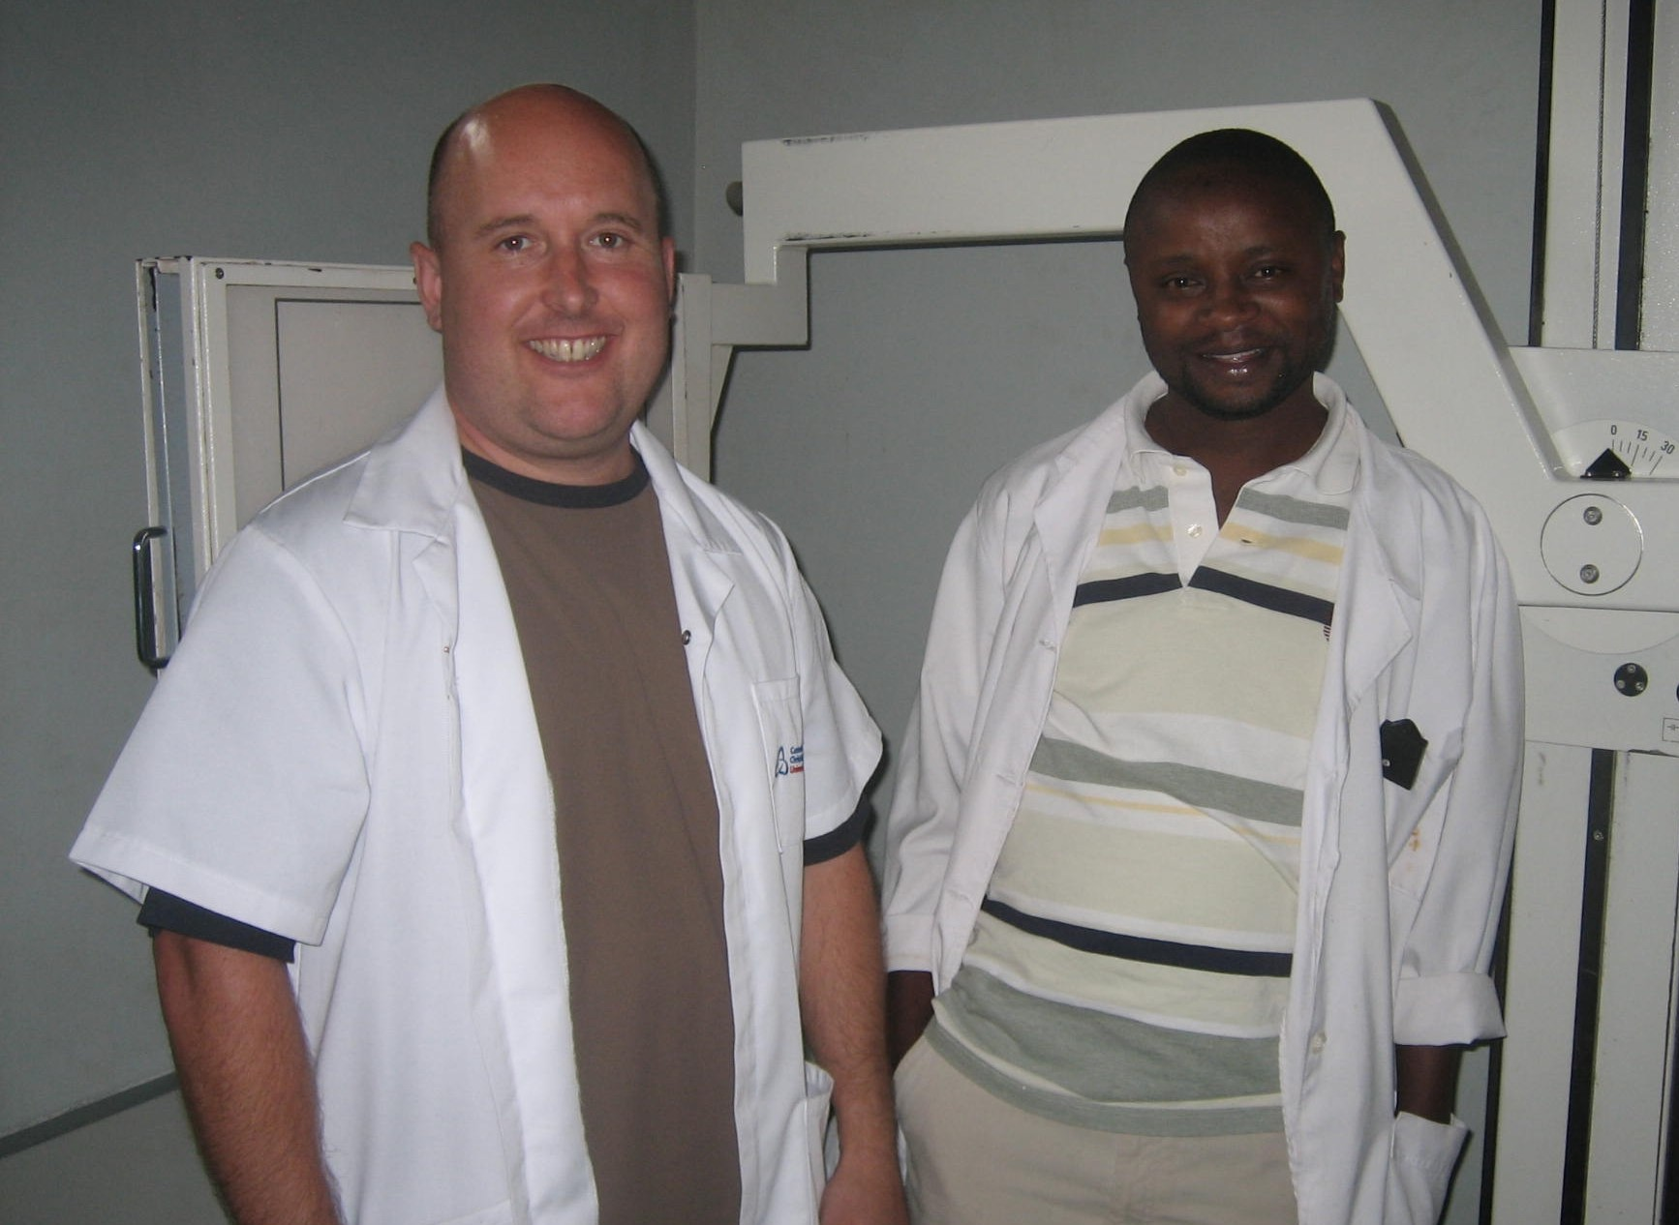

References

- Tanzania Facts. Available from: https://www.cia.gov/library/publications/the-world-factbook/geos/tz.html (accessed 06-11-2011)
- Spring, J. (2011) “Radiography in remote Northern Ghana – Recent Experiences” Available from: http://www.afrikids.org/pdf/Radiography%20in%20Remote%20Northern%20Ghana.pdf (accessed 17/09/2011)
- Carter, S. (2003) “Imaging in Ghana” Synergy, April 2003: 20-23
- Motec Life-UK. Available from http://www.moteclife.co.uk/documents.htm (accessed 05/09/2010)
- Health service system structure. Available from: http://www.tanzania.go.tz/health.html (accessed 17/09/2011)
- The CanAssist African Relief Trust. Available from: http://canassistafrica.ca/Meru.htm (accessed 17/09/2011)
- World Health Organisation (WHO) Basic Radiology System (BRS). Available from: http://www.wpro.who.int/internet/files/pub/297/annex8.pdf (accessed 20/09/11)
- Sungita, Y. Mdoe, S. Msaki, P. (2006) Diagnostic X-ray facilities as per quality control performances in Tanzania. Journal of Applied Clinical Medical Physics, Volume 7.

